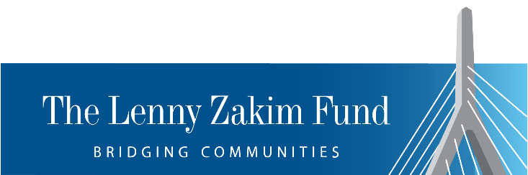
Charitable Bequest Information
What is a charitable bequest? A gift given by a donor when s/he designates an organization to receive a specific amount or percentage of his/her estate through a will or revocable living trust.

Gifts by will are generally simple to make and offer these advantages:
- Control: assets named in a bequest remain in the donor’s control throughout his/her lifetime
- Affordability: even small bequests will have an impact on ensuring LZF’s successful future
- Flexibility: donors can leave a specific amount of money to the LZF, make a gift contingent on certain events, or leave a percentage of his/her estate to the LZF (often the preferred choice in order to take care of family members first) AND all of this can be changed by the donor until his/her death
- Tax Relief: a charitable bequest is entitled to an estate tax charitable deduction, for those individuals who are subject to estate taxes
- Impact: an unrestricted bequest allows the LZF to use the assets in the most beneficial way at the time the gift is received. A restricted bequest allows the donor to specify how the LZF uses the funds. We encourage a donor who intends to restrict a bequest to talk with us first in order to ensure that it can be used in a thoughtful way in the future

Bequest Language to be shared with any individual who is interested:

Specific bequest language - "I give, devise and bequeath (describe property to be given, ex. $100,000, 100 shares of Apple stock) to the Lenny Zakim Fund, Inc., located in Boston, MA, for its general programmatic and charitable purposes."

Residuary bequest language – "I give, devise and bequeath (choose a percentage to be given, ex. 50) percentage of my residuary estate to the Lenny Zakim Fund, Inc., located in Boston, MA, for its general programmatic and charitable purposes." [I.E., The LZF will receive that percentage of the remaining balance of the estate once specific distributions are made and all obligations have been satisfied.]

Contingent bequest language – "I give, devise and bequeath $100,000 to the Lenny Zakim Fund, Inc., located in Boston, MA, for its general programmatic and charitable purposes, should (insert a condition, ex., If my spouse is not living at the time of my demise)."

These examples are phrased to provide unrestricted support; any of them may be tweaked to become a restricted bequest for a specific purpose (to add to an existing named endowed fund, to support a specific program of special interest, etc.). Again, we encourage discussion of restricted funds before a bequest is formalized.

The Lenny Zakim Fund Tax I.D. #04-3485146

For more information, please contact Allison Picott, Director of Development
The Lenny Zakim Fund
33 Arch Street, 26th Floor
Boston, MA 02110
cbeaudoin@thelennyzakimfund.org
617-406-5945

